EXP NO: 6
Aim
Play video in slow motion using OpenCV library.
Algorithm (6 Steps, 7 Words Each)
- Import OpenCV library for video processing operations.
- Open video file using VideoCapture function successfully.
- Read video frames continuously inside while loop.
- Display each frame using OpenCV imshow function.
- Delay frame display creating slow motion effect.
- Release resources and close all display windows.
Code
import cv2

cap = cv2.VideoCapture(r"C:\Users\ADMIN\Downloads\video.mp4")

while cap.isOpened():
ret, frame = cap.read()

if not ret:
break

cv2.imshow("Slow Motion", frame)

if cv2.waitKey(100) & 0xFF == ord('q'):
break

cap.release()
cv2.destroyAllWindows()
Output:
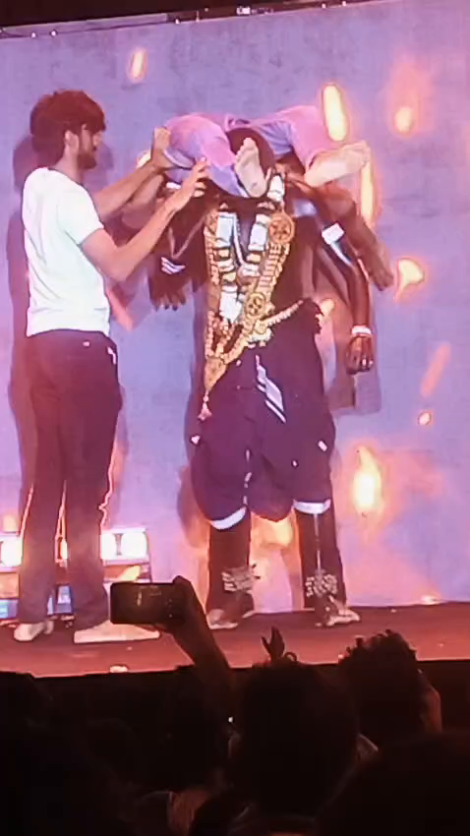

Result
The video was successfully played in slow motion, and playback stopped when the video ended or the 'q' key was pressed.

